Return Address Labels Order Form – To Benefit Amaranth Diabetes Foundation
Name:___________________________________ Court:_________________________
Address:_________________________________________________________________
City:__________________________________ State:___________ Zip:_______________
Additional Line (if desired):__________________________________________________
If you want labels different than your shipping address above, please use this space
below (up to four lines):
How would you like your address labels laid out
☐ centered ☐left justified ☐ right justified

How many labels would you like printed?
☐ 30 labels for $5 ☐90 labels for $10
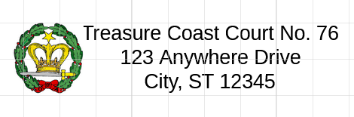  (three lines – centered) |  | 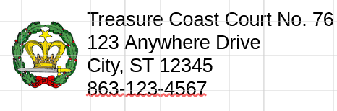  (four lines – left justified)
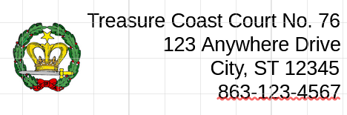
(four lines – right justified)
Please send this form to any of the following methods:
Email: nelson.tanya.j@gmail.com
Text an image: 561-301-4174
Regular Mail: Tanya Nelson
1141 SW Kalevala Drive
Port Saint Lucie, FL 34953
Make checks payable to Treasure Coast Court No 76.
If you’re requesting a specific image, please provide that when sending in the form or contact me and I would be happy to find a satisfactory image.
“A copy of the official registration and financial information may be obtained from the division of consumer services by calling 800-435-7352 within the state registration does not imply endorsement, approval, or recommendation by the state” ch2840

